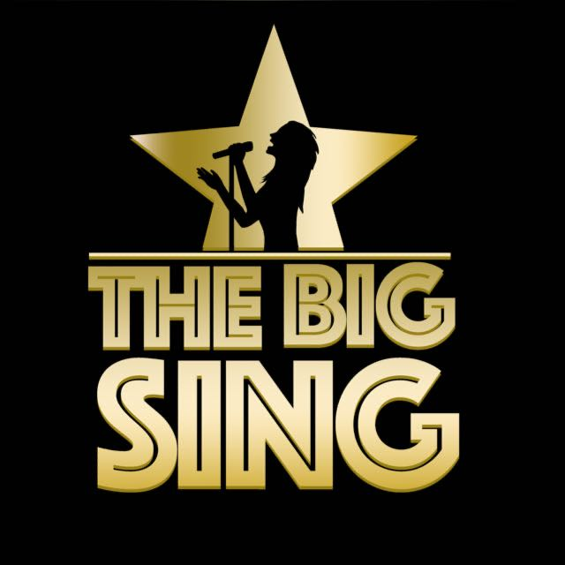
Song Title: Something Like This/Faoi Na Soilse/Viva La Vida
Artist: Coldplay/Lurgan
Genre: Pop
Original Key:
Our Key:

Important Notes For Teachers
- Only use The Big Sing tracks and demo tracks for teaching all songs (keys, structures and some lyrics have been altered in some songs)
- If parts of the lyrics are highlighted in bold, this means that the children only sing these parts of the songs.
- The tracks and demo tracks are downloadable which means they can easily be shared for preparation for homework if needs be.

Possible Curricular Objectives
History
- Explore the French Revolution (Viva la Vida is based on the story of King Louis’ last speech during the French Revolution)
- Greek Mythology (Hercules, Achillies)
Music
- Enjoying listening and responding to music.
- Compare and contrast slow/fast parts of the song.
- Keep the beat of the song when performing.
- Explore different rhythms and melodic movements in the song.
- Explore and identify the structure of the song.
- Identify different instruments in the song.
- Become aware of loud and soft moments in the song (dynamics).
- Discussing personal preferences and comparing songs chosen for the Big Sing.
- Perform and record singing to listen back to and self assess.
Literacy
- Song writing (using elements like repetition, exploring syllabic movements and rhyming words).
- Explore comic books and characters such as Spider Man and Batman.
- Children could study comics and create their own comic stories.

Lyrics

I've been reading books of old
The legends and the myths
Achilles and his gold
Hercules and his gifts
Spider-Man's control
And Batman with his fists
And clearly I don't see myself upon that list

But she said, where'd you wanna go?
How much you wanna risk?
I'm not lookin' for somebody
With some superhuman gifts
Some superhero
Some fairy-tale bliss
Just something I can turn to
Somebody I can kiss

I want something just like this
Doo-doo-doo, doo-doo-doo
Doo-doo-doo, doo-doo
Doo-doo-doo, doo-doo-doo
Oh, I want something just like this
Doo-doo-doo, doo-doo-doo
Doo-doo-doo, doo-doo
Doo-doo-doo, doo-doo-doo
Oh, I want something just like this
Oh, I want something just like this
Oh, I want something just like this

Faoi na soilse ag lonradh thuas os mo chionn.
Tá mé ag tair-iscint mo chroí.
Faoi na soilse ag lonradh thuas os mo chionn.
Tá sí ar tosach na slí.
Tá mé saor ach is léir nach bhfuil tú.
Do mo strói-ceadh ‘tá tú.
‘Sé faoi na soilse ag lonradh thuas os mo chionn.
Go bhfeicfidh mé thúuuu
Bam bam bam badada bam bam bam badada.
Bam bam bam badada bam bam bam badada.
Bam bam bam badada bam bam bam badada.
Bam bam bam badada bam bam bam badada.

I used to rule the world
Seas would rise when I gave the word
Now in the morning, I sleep alone
Sweep the streets I used to own

I used to roll the dice
Feel the fear in my enemy's eyes
Listen as the crowd would sing
Now the old king is dead, long live the king
One minute, I held the key
Next the walls were closed on me
And I discovered that my castles stand
Upon pillars of salt and pillars of sand

I hear Jerusalem bells a-ringin'
Roman Cavalry choirs are singin'
Be my mirror, my sword and shield
My missionaries in a foreign field
For some reason, I can't explain
Once you'd gone, there was never, never an honest word
And that was when I ruled the world
Woah-oh-oh, oh-oh, oh Woah-oh-oh, oh-oh, oh
Woah-oh-oh, oh-oh, oh Woah-oh-oh, oh-oh, oh
Woah-oh-oh, oh-oh, oh Woah-oh-oh, oh-oh, oh
Woah-oh-oh, oh-oh, oh Woah-oh-oh, oh-oh, oh
Woah-oh-oh, oh-oh, oh Woah-oh-oh, oh-oh, oh
Woah-oh-oh, oh-oh, oh Woah-oh-oh, oh-oh, oh
Woah-oh-oh, oh-oh, oh Woah-oh-oh, oh-oh, oh
Woah-oh-oh, oh-oh, oh Woah-oh-oh, oh-oh, ooooooooh

