Kilmessan Mixed N.S.

Mission Statement

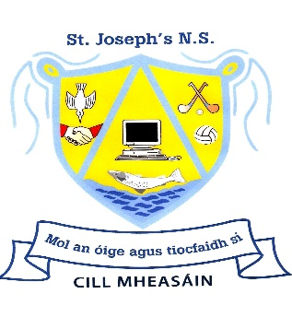
- Kilmessan Mixed N.S. is a co-educational, Catholic primary school which strives to provide a well-ordered, caring, happy and secure atmosphere where the intellectual, spiritual, physical, moral and cultural needs of the pupils are identified and addressed.
- While Kilmessan Mixed N.S. is a primary school with a Catholic ethos, it also has due recognition & respect for all other religions and cultures.
- When our pupils leave us, it is our aim that they will have achieved their potential in literacy and numeracy and will be enabled to utilise these skills to pursue further learning and become active members of their community & of wider society.
- Our school is an integral part of the parish of Kilmessan. Therefore, we will encourage the involvement of parents & the wider community through home/school/community contacts and through their involvement with the P.A. & the Board of Management.
- Pupils will be enabled to make moral judgements based on their Christian values, human rights and their own conscience that will contribute to a caring, tolerant and accepting society.
- We will foster positive attitudes towards physical fitness and nutrition and encourage healthy habits that will enable pupils to reach their full physical potential.
- We will foster in the pupils the knowledge that with every right, there is a corresponding responsibility.
- We will endeavour to enhance the self esteem of everyone in the school community.
- We will promote gender equity amongst all staff and pupils.
- Déanfaimid iarracht Gaeilge a labhairt agus cultúr na tíre a chur chun cinn.
- School motto – “Mol an Óige agus tiocfaidh sí”

