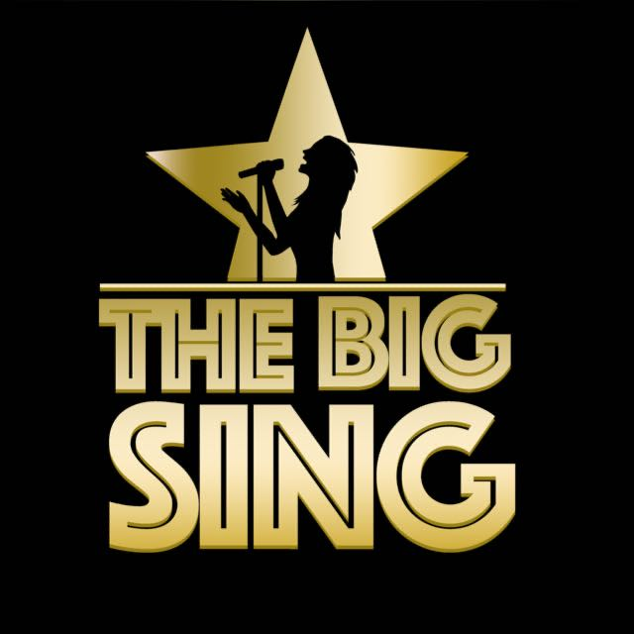
Song Title: Jai Ho
Artist: A.R. Rahman/Pussycat Dolls
Genre: Indian Pop
Original Key: G sharp Minor/B Major
Our Key: G sharp Minor/B Major

Important Notes For Teachers
- Only use The Big Sing tracks and demo tracks for teaching all songs (keys, structures and some lyrics have been altered in some songs)
- If parts of the lyrics are highlighted in bold, this means that the children only sing these parts of the songs.
- The tracks and demo tracks are downloadable which means they can easily be shared for preparation for homework if needs be.
- Phonetics pronunciations are included to help children with pronunciations of hindi lyrics.

Possible Curricular Objectives
S.E.S.E
- Do a project all about India and different aspects of its history and culture.
- Explore different landmarks in India.
- Compare life in Ireland to Life in India.

Music
- Enjoying listening and responding to music.
- Compare and contrast slow/fast parts of the song.
- Keep the beat of the song when performing.
- Explore different rhythms and melodic movements in the song.
- Explore and identify the structure of the song.
- Identify different instruments in the song.
- Become aware of loud and soft moments in the song (dynamics).
- Discussing personal preferences and comparing songs chosen for the Big Sing.
- Perform and record singing to listen back to and self assess.
PE
- Learn traditional Indian dance moves and create your own dance sequence using a mix of Indian and Irish dance moves (fusion).
Jai Ho Lyrics
Jai Ho!
Aaja-aaja jind (ajah ajah gin-dee)
shamiyane Ke tale (sha-mee yanny kee-ta-lay-ah)
Aaja jariwale nile aasman (ja jir-ee waly neely asa-man-ay)
ke tale (kee-ta-lay-ah)

Aaja-aaja jind (ajah ajah gin-dee)
shamiyane Ke tale (sha-mee yanny kee-ta-lay-ah)
Aaja jariwale nile aasman (ja jir-ee waly neely asa-man-ay)
ke tale (kee-ta-lay-ah)

You are the reason that I breathe; you are the reason that I still believe
You are my destiny Jai Ho, o-o-o-oh!
No, there is nothing that can stop us; nothing can ever come between us
So come and dance with me Jai Hoooo!

Guest Performer Section
Jai Ho! Jai Ho!
Aaja-aaja jind (ajah ajah gin-dee)
shamiyane Ke tale (sha-mee yanny kee-ta-lay-ah)
Aaja jariwale nile aasman (ja jir-ee waly neely asa-man-ay)
ke tale (kee-ta-lay-ah)

Aaja-aaja jind (ajah ajah gin-dee)
shamiyane Ke tale (sha-mee yanny kee-ta-lay-ah)
Aaja jariwale nile aasman (ja jir-ee waly neely asa-man-ay)
ke tale (kee-ta-lay-ah)

You are the reason that I breathe; you are the reason that I still believe
You are my destiny Jai Ho, o-o-o-oh!
No, there is nothing that can stop us; nothing can ever come between us
So come and dance with me Jai Hoooo!

Guest Performer Section

Jai Ho! Jai Ho!

You are the reason that I breathe; you are the reason that I still believe
You are my destiny Jai Ho, o-o-o-oh!
No, there is nothing that can stop us; nothing can ever come between us
So come and dance with me Jai Hoooo!
Jai Ho Baila Baila!
Jai Ho Baila Baila!
Jai Ho Baila Baila!
Jai Ho JAI HO!

