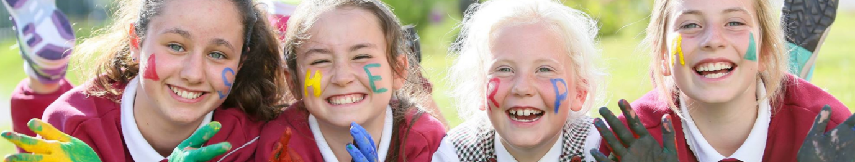
Dear School Families,
Following on from the discussions to support families with fun and engaging childcare solutions beyond the school day throughout the academic year, we’re delighted to inform you that we have partnered with Sherpa Kids as the school’s NEW Before and After School opening from 27/08/2025 at KILMESSAN NS
NEW Before and After School programmes coming to KILMESSAN NS
Sherpa Kids is Ireland’s leading school-age childcare provider offering programmes in over 90 locations across the country for over 10 years. Sherpa Kids offers an enriching experience that goes beyond the traditional school day, providing a safe and nurturing environment for your child to thrive with various engaging activities to keep them entertained and active during the day!
- Enriching activities for primary-aged children
- Market-leading term time and holiday programmes
- Build social skills and make new friends
- Weekly or Adhoc booking options
- NCS Subsidy Accepted
- Homework Supervision
- Tusla Registered Services
- Extended Hours (Up to 6pm Mon-Fri)
- Breakfast & Snack Provided
We’re excited to be opening Sherpa Kids here at KILMESSAN NS on 27/08/2025!
Check out further details of Sherpa Kids services below:
🌅 Before School Programmes (Rise then Shine)
Sherpa Kids Before School Programmes prepare children’s minds and bodies for a busy day at school day while offering a hassle-free morning for families with no worries when dropping their children early in school. A healthy and nutritious breakfast is offered to keep them energised throughout their day while focusing on an active start with activities that stimulate concentration and provide well-being.
- Rise then Shine / Before School starts at 8am and runs until the start of school.
👉 Book now at: https://enrolmy.com/sherpa-kids/book-now/308-KMNSM-NEW-YEAR-Aug25-Jun26-Rise-Then-Shine-Before-School-and-Stay-and-Play-After-School

👉 Find out more at: https://www.sherpakids.ie/before-and-after-school/rise-then-shine-before-school/

🤸 After School Programmes (Stay and Play)
Sherpa Kids offers After School Programmes starting when Junior and Senior infants finish their classes and extending beyond school hours. During their time at Sherpa Kids in the afternoon, they’ll have homework support, time to play freely and dive into engaging and fun games and activities fostering friendship, teamwork, and well-being.
- Stay and Play / Junior Hour After School starts at 1:40 pm until older siblings are picked up.
- Stay and Play / After School starts at 1:40 pm and runs until 6:00 pm.
👉 Book now at: https://enrolmy.com/sherpa-kids/book-now/308-KMNSM-NEW-YEAR-Aug25-Jun26-Rise-Then-Shine-Before-School-and-Stay-and-Play-After-School

👉 Find out more at: https://www.sherpakids.ie/before-and-after-school/stay-and-play-after-school/

National Childcare Scheme
🎉 National Childcare Scheme
Sherpa Kids is a Tusla registered service which means they support and accept the National Childcare Scheme across all their services and programmes, including Holiday Programmes. As a parent/guardian, you are entitled to claim a discount of €2.14 up to €3.75 per hour off your bill. 🎉
👉 Find out more: https://www.sherpakids.ie/parent-support/national-childcare-scheme-ncs/
To learn more about Sherpa Kids:
- Sherpa Kids Website: https://www.sherpakids.ie/.
- Sherpa Kids Story: https://www.sherpakids.ie/about-us/
- Support: https://www.sherpakids.ie/parent-support/
- FAQs: https://www.sherpakids.ie/parent-support/frequently-asked-questions/
- Sherpa Kids Locations: https://www.sherpakids.ie/find-us/
Please, if you require any further information contact Sherpa Kids directly at https://www.sherpakids.ie/parent-support/ and they’ll be happy to assist you.
Yours sincerely,
KILMESSAN NS

