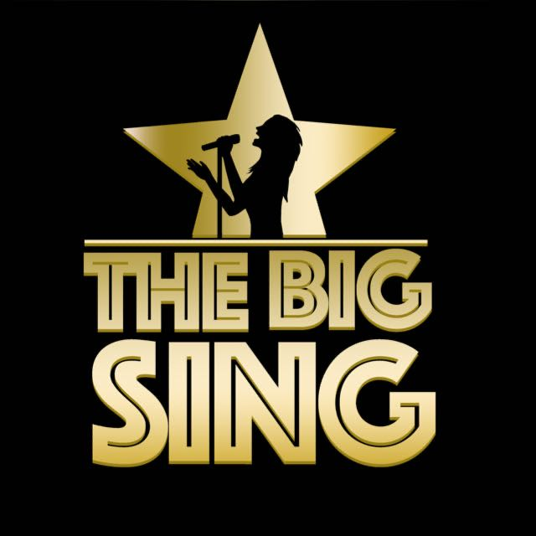
Song Titles: What Was I Made For/Dance The Night
Artist: Billie Eilish/Dua Lipa
Genre: Pop
Original Key: C Major/B Minor
Our Key: B flat Major/B Minor

Important Notes For Teachers
- Only use The Big Sing tracks and demo tracks for teaching all songs (keys, structures and some lyrics have been altered in some songs)
- If parts of the lyrics are highlighted in bold, this means that the children only sing these parts of the songs.
- The tracks and demo tracks are downloadable which means they can easily be shared for preparation for homework if needs be.

Possible Curricular Objectives
S.P.H.E/Drama.
- Explore and discuss a range of feelings and emotions we feel
- Mime different feelings
- Recreate scenes/role plays using characters from Barbie
Music
- Enjoying listening and responding to music.
- Compare and contrast slow/fast parts of the song.
- Keep the beat of the song when performing.
- Explore different rhythms and melodic movements in the song.
- Explore and identify the structure of the song.
- Identify different instruments in the song.
- Become aware of loud and soft moments in the song (dynamics).
- Discussing personal preferences and comparing songs chosen for the Big Sing.
- Perform and record singing to listen back to and self assess.
- Compare the 2 songs and share their personal preferences
Literacy
- Song writing (using elements like repetition, exploring syllabic movements and rhyming words).
PE
- Create some simple dance sequences to accompany both songs (slow/fast movements)
Barbie Lyrics
I used to float, now I just fall down
I used to know but I'm not sure now
What I was made for
What was I made for?

Takin' a drive, I was an ideal
Looked so alive, turns out I'm not real
Just something you paid for
What was I made for?

'Cause I, I
I don't know how to feel
But I wanna try
I don't know how to feel
But someday, I might….Someday, I might

Baby, you can find me under the lights
Diamonds under my eyes
Turn the rhythm up, don't you wanna just
Come along for the ride?
Oh, my outfit so tight
You can see my heartbeat tonight
I can take the heat, baby, best believe
That's the moment I shine

'Cause every romance shakes and it bends
Don't give a damn
When the night's here, I don't do tears Pre-Chorus
Baby, no chance
I could dance, I could dance, I could dance

Watch me dance, dance the night away
My heart could be burnin', but you won't see it on my face
Watch me dance, dance the night away Chorus
I'll still keep the party runnin', not one hair out of place

Lately, I've been moving close to the edge
Still be lookin' my best
I stay on the beat, you can count on me
I ain't missin' no steps

'Cause every romance shakes and it bends
Don't give a damn
When the night's here, I don't do tears Pre-Chorus
Baby, no chance
I could dance, I could dance, I could dance

Watch me dance, dance the night away
My heart could be burnin', but you won't see it on my face
Watch me dance, dance the night away Chorus
I'll still keep the party runnin', not one hair out of place
Dance the night!

