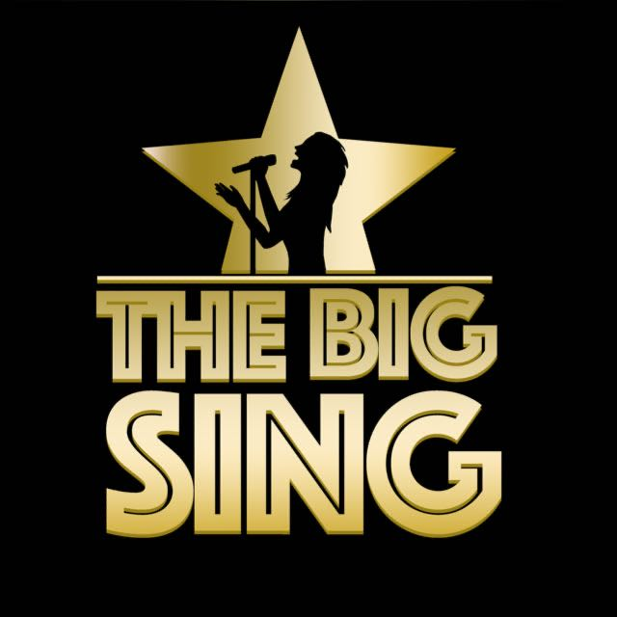
Song Title: I’m Still Standing
Original Artist: Elton John Version: ‘Sing’
Genre: Pop
Original Key: C Major
Our Key: C Major

Important Notes For Teachers
- Only use The Big Sing tracks and demo tracks for teaching all songs (keys, structures and some lyrics have been altered in some songs)
- If parts of the lyrics are highlighted in bold, this means that the children only sing these parts of the songs.
- The tracks and demo tracks are downloadable which means they can easily be shared for preparation for homework if needs be.

Possible Curricular Objectives
History
- Explore the history and success of Elton John.

S.P.H.E/Drama.
- Explore what resilience and perseverance means.
- Share moments where the children had resilience and persevered when something was challenging.
- Discuss and act out scenarios that display perseverance and resilience.
Music
- Enjoying listening and responding to music.
- Compare and contrast slow/fast parts of the song.
- Keep the beat of the song when performing.
- Explore different rhythms and melodic movements in the song.
- Explore and identify the structure of the song.
- Identify different instruments in the song.
- Become aware of loud and soft moments in the song (dynamics).
- Discussing personal preferences and comparing songs chosen for the Big Sing.
- Perform and record singing to listen back to and self assess.
Literacy
- Song writing (using elements like repetition, exploring syllabic movements and rhyming words).
I’m Still Standing Lyrics

You could never know what it's like
Your blood like winter freezes just like ice
And there's a cold lonely light that shines from you
You'll wind up like the wreck you hide behind that mask you use

And did you think this fool could never win?
Well look at me, I'm coming back again
I got a taste of love in a simple way
And if you need to know while I'm still standing, you just fade away

Don't you know I'm still standing better than I ever did
Looking like a true survivor, feeling like a little kid
I'm still standing after all this time
Picking up the pieces of my life without you on my mind Chorus
I'm still standing, yeah, yeah, yeah
I'm still standing, yeah, yeah, yeah

Once I never could hope to win
You starting down the road leaving me again
The threats you made were meant to cut me down
And if our love was just a circus, you'd be a clown by now

Don't you know I'm still standing better than I ever did
Looking like a true survivor, feeling like a little kid
I'm still standing after all this time
Picking up the pieces of my life without you on my mind Chorus
I'm still standing, yeah, yeah, yeah
I'm still standing, yeah, yeah, yeah

Instrumental

Don't you know I'm still standing better than I ever did
Looking like a true survivor, feeling like a little kid
I'm still standing after all this time
Picking up the pieces of my life without you on my mind Chorus
I'm still standing, yeah, yeah, yeah
I'm still standing, yeah, yeah, yeah
I'm still standing, yeah, yeah, yeah
I'm still standing, yeah, yeah, yeeeaaaaaah…YEAH!

