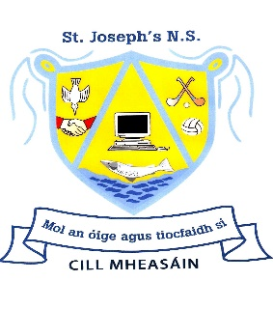
Healthy Eating Policy
A key element of our SPHE (Social, Personal & Health Education) Programme is encouraging pupils to be aware of healthy lifestyle choices, including the importance of a balanced, nutritious diet.
What people eat is known to be a key factor influencing health. Research indicates a strong link between diet & performance (eg. A lower sugar intake promotes better concentration, lessens hyperactivity, protects teeth & lowers the risk of developing Type 2 diabetes & obesity. A lower salt intake reduces the risk of heart disease in later life). It is the responsibility of parents & guardians to ensure that children have a healthy balanced, nutritional lunch at school daily.
Lunch is a very important meal for school-going children. It should provide approximately one third of their recommended daily nutritional intake, without being high in sugar, salt or fat.
The following guide is based on the food pyramid (overleaf) & contains some suggestions for quick, appetizing & nutritious lunches for pupils. The list is not exhaustive. There are many more alternative options not listed below (see www.safefood.eu for more ideas).
Bread & Alternatives | Fruit & Vegetables
Bread or rolls –preferably wholemeal/wholegrain  Rice –preferably wholegrain  Pasta –preferably wholegrain  Bagels or Pitta pockets  Bread sticks or crackers  Wholemeal scones  Wraps  Rice cakes | Fruit & Berries  Seedless grapes cut  Carrot, celery or cucumber sticks (with a dip)  Cherry tomatoes, sweetcorn  Coleslaw  Salad leaves  Potato salad  Seeds (sunflower, pumpkin, sesame etc.)
Savouries & Fillings | Drinks
Lean meat  Chicken/turkey  Tinned fish (sardines, salmon, tuna etc.)  Cheese  Eggs (scrambled, poached, hard-boiled)  Beans  Chickpeas  Vegetarian Sausage  Tofu | Water (not flavoured)  Milk (not flavoured)

One small treat is permitted on Fridays. Suggestions include a fun-size bar, fun-size packet of sweets, some chocolate, a small biscuit, a cereal bar etc. The pupils are encouraged to eat their treat after their healthy lunch has been eaten.
We have a number of children in the school who have heightened sensitivities or allergies (in some cases, potentially fatal) to certain foods. As a result, we request that certain foods not be included in your child’s lunchbox (e.g. nuts & nut products). Also, please remind your child not to share or swap lunches. Unfortunately we cannot accept home baked foods to share among classmates.

We ask that the following items are NOT brought to school
- Chewing gum
- Crisps (or crisp-style snacks)
- Fizzy drinks, sports/energy drinks, juices with a high sugar content, flavoured water
- Drinks in glass bottles
- Nut products (including Nutella)
- Sweets or lollipops
- Biscuits, bars, cereal bars (unless home-made & on Treat Day)
- Fruit winders
- Fast food (chips, wedges etc.)

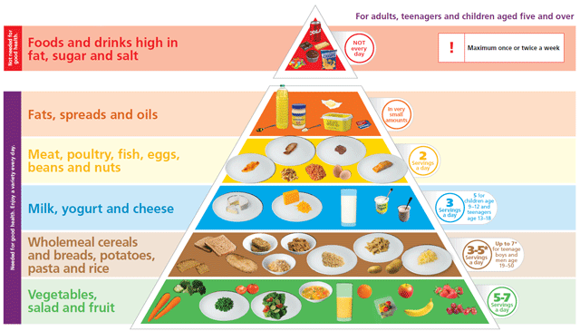
Note:
As part of the Green Schools Programme, it is important that packaging of school lunches is kept to a minimum. All wrapping, waste and uneaten food will be returned home in the lunch box.

Signed on behalf of the Board of Management:

Chairperson:___________________ Date:__________________

Principal: ______________________ Date:__________________

