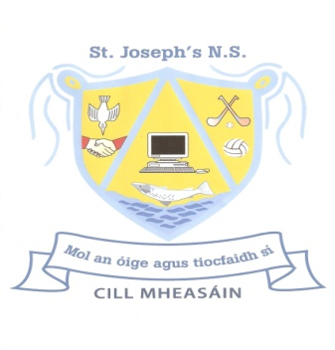
Kilmessan Mixed NS
School Uniform Policy
The School Uniform consists of:
- Dark Grey trousers, skirt or pinafore dress
- Dark Grey tracksuit bottoms are permitted during cold weather only
- Shorts, if worn, must be dark grey or navy (in keeping with uniform/tracksuit).
- Pale blue shirt or polo t-shirt (no tie necessary)
- Dark grey v-neck jumper/sweater/cardigan.
- Suitable footwear.
The items listed above are generic & may be purchased at very reasonable cost in any clothing store or supermarket.
The school P.E. tracksuit, consisting of red Polo t-shirt, navy top and bottoms is available to purchase exclusively from Ted Murtagh’s Clothes Shop, Trim. The tracksuit may be worn ONLY on the following occasions.
- Day(s) allocated for class P.E.
- Swimming/Sports Day/ School trips.
- Days of school football, hurling, camogie, soccer matches etc.
On other days when children are training for hurling, football etc., a change of clothing and footwear must be worn at lunchtime only.
Small stud earrings are the only piercings permitted.
Make-Up is not permitted.

Ratified by the Board of Management of Kilmessan Mixed NS on __________________
Signed ____________________Chairperson

Review Date: 2017-18

