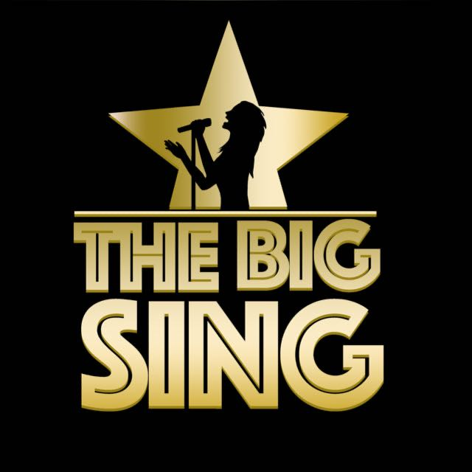
Song Title: Thank You For The Music
Artist: Abba
Genre: Pop
Original Key:
Our Key:

Important Notes For Teachers
- Only use The Big Sing tracks and demo tracks for teaching all songs (keys, structures and some lyrics have been altered in some songs)
- If parts of the lyrics are highlighted in bold, this means that the children only sing these parts of the songs.
- The tracks and demo tracks are downloadable which means they can easily be shared for preparation for homework if needs be.

Possible Curricular Objectives
History
- Explore the success of Abba

Music
- Enjoying listening and responding to music.
- Compare and contrast slow/fast parts of the song.
- Keep the beat of the song when performing.
- Explore different rhythms and melodic movements in the song.
- Explore and identify the structure of the song.
- Identify different instruments in the song.
- Become aware of loud and soft moments in the song (dynamics).
- Discussing personal preferences and comparing songs chosen for the Big Sing.
- Perform and record singing to listen back to and self assess.
- Discuss what the world would be like without Music. Why do we love Music so much?

Thank You For The Music Lyrics
This song will be performed with a range of Guest Performers

I'm nothing special, in fact I'm a bit of a bore
If I tell a joke, you've probably heard it before
But I have a talent, a wonderful thing
'Cause everyone listens when I start to sing
I'm so grateful and proud
All I want is to sing it out loud

So I say
Thank you for the music, the songs I'm singing
Thanks for all the joy they're bringing
Who can live without it? I ask in all honesty
What would life be?
Without a song or a dance, what are we?
So I say thank you for the music
For giving it to me

Mother says I was a dancer before I could walk
She says I began to sing long before I could talk
And I've often wondered, how did it all start?
Who found out that nothing can capture a heart
Like a melody can?
Well, whoever it was, I'm a fan

So I say
Thank you for the music, the songs I'm singing
Thanks for all the joy they're bringing
Who can live without it? I ask in all honesty
What would life be?
Without a song or a dance what are we?
So I say thank you for the music
For giving it to me

I've been so lucky, I am the girl with golden hair
I wanna sing it out to everybody
What a joy, what a life, what a chance

Thank you for the music, the songs I'm singing
Thanks for all the joy they're bringing
Who can live without it, I ask in all honesty
What would life be?
Without a song or a dance what are we?
So I say thank you for the music
For giving it to me
So I say
Thank you for the music, for giving it to…. me

